**Optimizing Deep Learning Models for Atypical Teratoid Rhabdoid Tumor Classification using AdamW and Vision Transformers**

**Hardware Requirement:**

* Processor: Intel i5 11th generation or above
* RAM: 16GB or more
* OS: Windows 11, 64-bit

**Software Requirement:**

* Spyder (Anaconda 3)

**How to use Spyder in windows**

1. Search Anaconda Navigator in Google search. (<https://www.anaconda.com/products/distribution>)
2. Download Anaconda Navigator and execute the file.
3. Then open anaconda navigator (anaconda 3) from windows search.
4. Scroll down and find Spyder and click launch button.
5. It will install automatically complete the installation.

**Execution Steps:**

1. Open Spyder IDLE
2. Unzip the code file and Load the Given Script (**Main.py**) to Spyder IDE.
3. Run the Script in Spyder IDE
4. You will see the output in the Output window.

Make sure to install necessary packages  
**To install packages**   
 open **Anaconda prompt**-> type these command and click enter to execute the command.

The command are:

* pip install numpy
* pip install scipy
* pip install pillow
* pip install torch torchvision
* pip install matplotlib
* pip install torchinfo
* pip instal scikit-plot
* pip install scikit-learn
* pip install seaborn
* pip install tensorflow
* pip install keras

**Instructions:**

**For example:-**

Open **Anaconda Prompt** and type a command

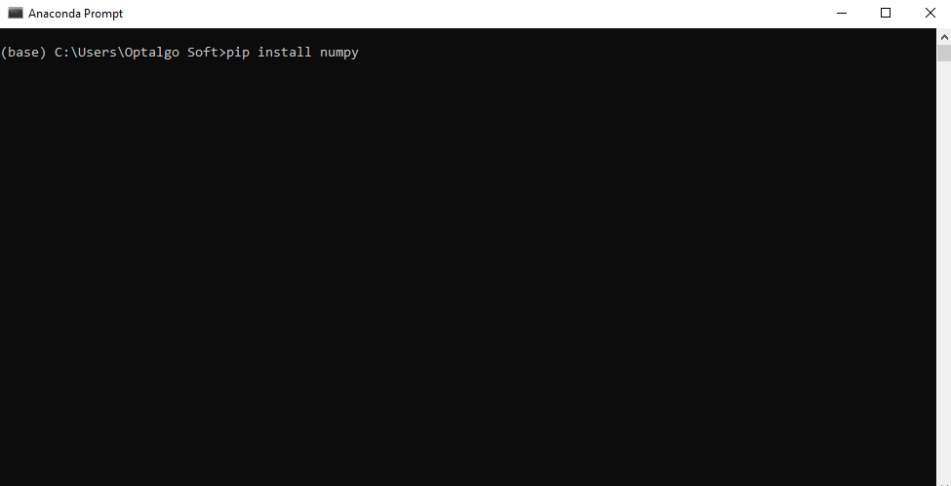

Click **enter**

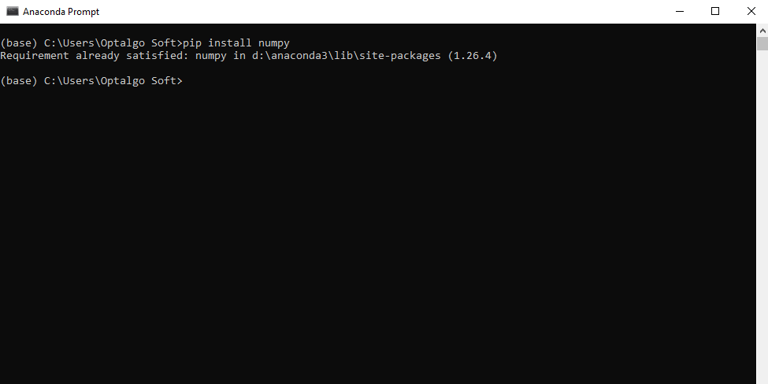

Follow this instruction and type and install all the commands.

**To execute the code**1. First extract the zip file

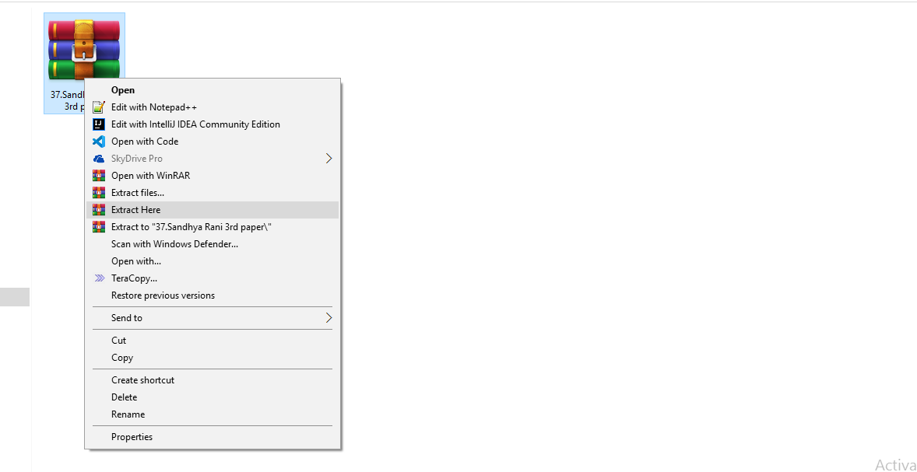

Click the **Extract Here** option to unzip the file

2. After extracting the zip file open **Spyder** application

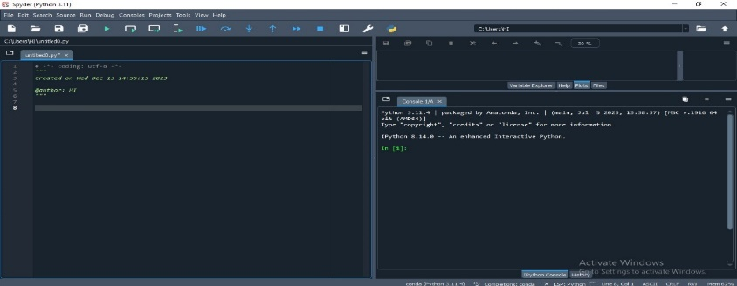

3. To Load the **Main.py** from extracted files  
and run

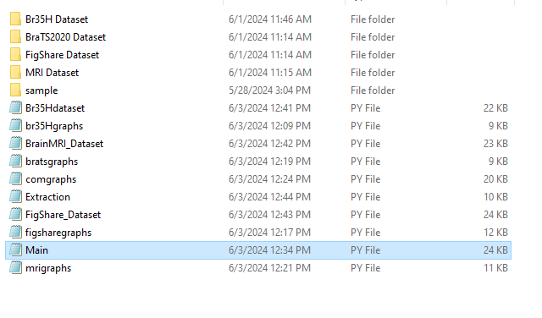

To load **Main.py**

Click **File**🡪**Open**

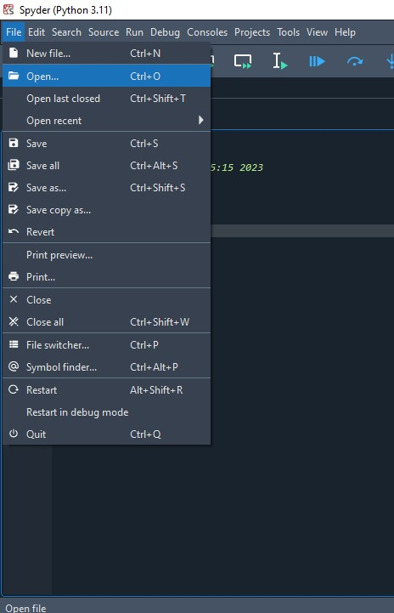

Browse and select the **Main.py** file from the extracted folder and click **Open**

Now the **Main.py** will be loaded like this

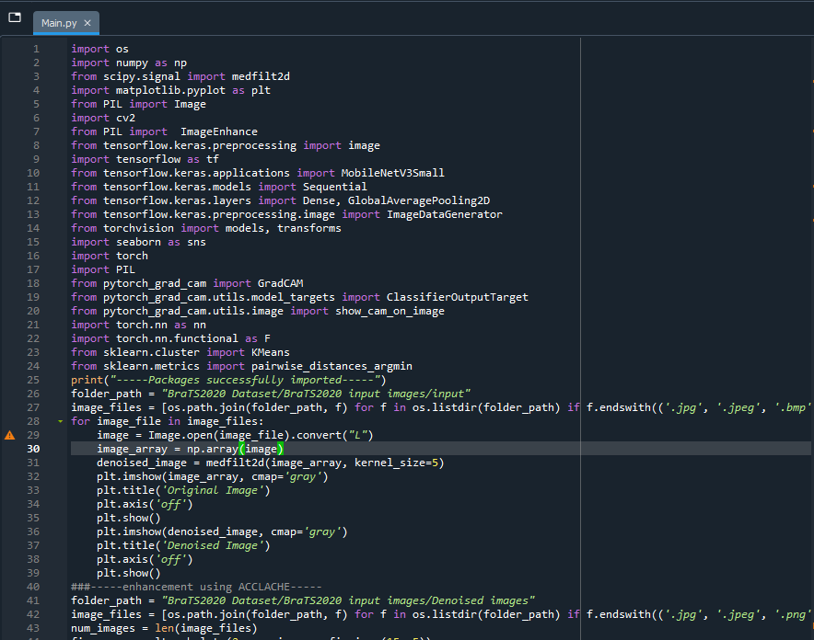

1. Now click **F5** to run the code or click **Run->Run** option in the menu bar to run the code.